Name

Mathematics Stage 5 Path
Coordinate Geometry Problems

Book 1 | Solve problems by applying coordinate geometry formulas | Version: 260314  Feedback:  https://MrDingMaths.com
Contents
Syllabus Content 2
Coordinate Geometry Problems: Triangles 3
Coordinate Geometry Problems: Quadrilaterals 10

Syllabus Content
MA5-LIN-P-01 describes and applies transformations, the midpoint, gradient/slope and distance formulas, and equations of lines to solve problems
Solve problems by applying coordinate geometry formulas
- Solve problems including those involving geometrical figures by applying coordinate geometry formulas

Coordinate Geometry Problems: Triangles

- Types of Triangles and their Properties
Type of Triangle | Definition
Equilateral Triangle | Three sides of equal length.
Isosceles Triangle | Two sides of equal length.
Right-angled Triangle | Side lengths satisfy Pythagoras’ Theorem or  Gradients of two sides are negative reciprocals.
Scalene Triangle | All side lengths different.

- Coordinate Geometry Formulas
Distance  $$d=\sqrt{{\left(x_{2}-x_{1}\right)}^{2}+{\left(y_{2}-y_{1}\right)}^{2}}$$ | Gradient  $$m=\frac{y_{2}-y_{1}}{x_{2}-x_{1}}$$  Parallel if $m_{1}=m_{2}$  Perpendicular if $m_{1}=-$ $\frac{1}{m_{2}}$ | Area of a Triangle  $$A=\frac{1}{2}bh$$  Where $b$ and $h$ are perpendicular to each other.

- Example Solve coordinate geometry problems involving triangles
A triangle has vertices at $A\left(1,-2\right), B\left(-4,2\right), C\left(5,-7\right).$
Find the lengths of the sides $AB$ and $AC$ and hence show it is isosceles.

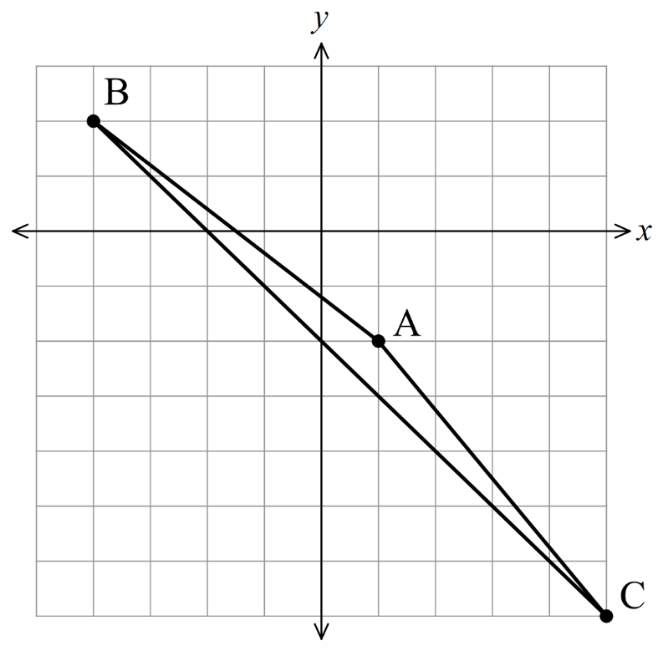
$$AB=\sqrt{{\left(-4-1\right)}^{2}+{\left(2-\left(-2\right)\right)}^{2}} \\ =\sqrt{41}$$

$$AC=\sqrt{{\left(5-1\right)}^{2}+{\left(-7-\left(-2\right)\right)}^{2}} \\ =\sqrt{41}$$

$AB=AC$, so $ΔABC$ is isosceles.

- Guided Practice
The vertices of the ΔABC are given by $A(0,0),B(9,12)$ and $C(25,0).$
  - Find the lengths of the three sides $AB, BC, AC$.
  - By checking that $AB^{2}+BC^{2}=AC^{2}$, show that $ΔABC$ is right-angled.

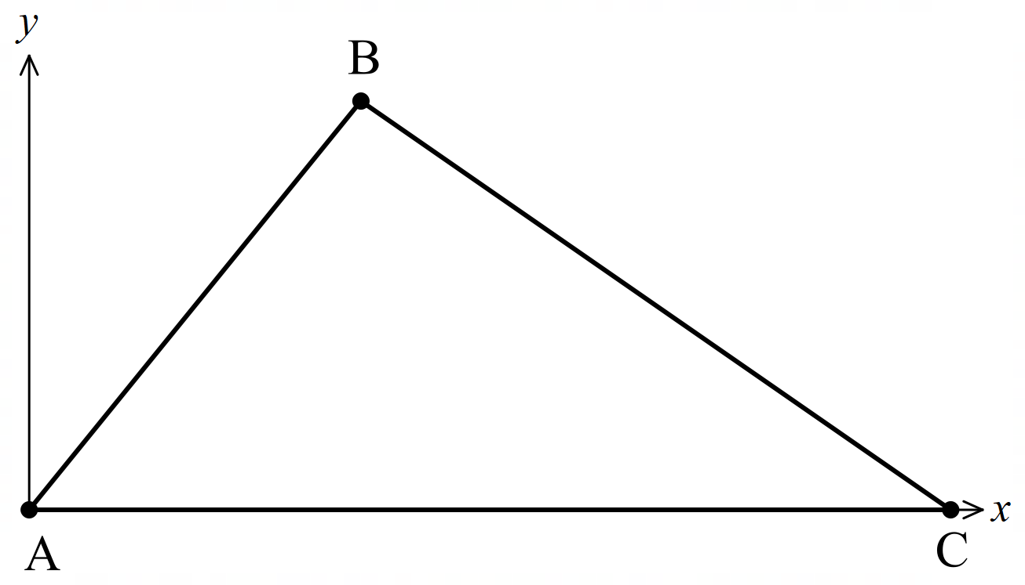

Triangle ABC has vertices at $A(1, 1), B(5, 3)$ and $C(4, 5).$
  - Find the gradients of line segments $AB$ and $BC$.
  - Hence show the area of the triangle is approximately 3.35 u².
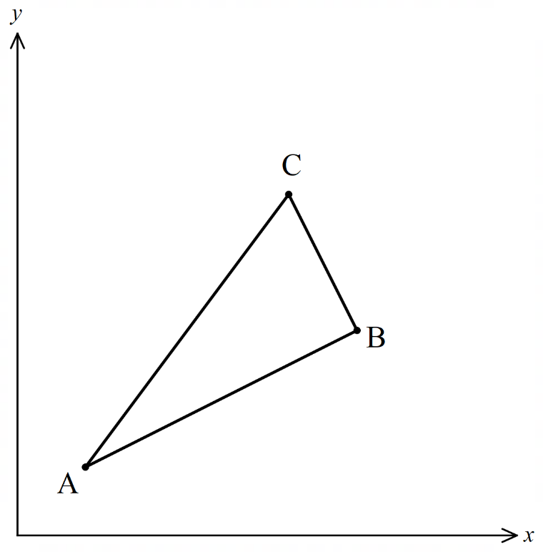

Foundation
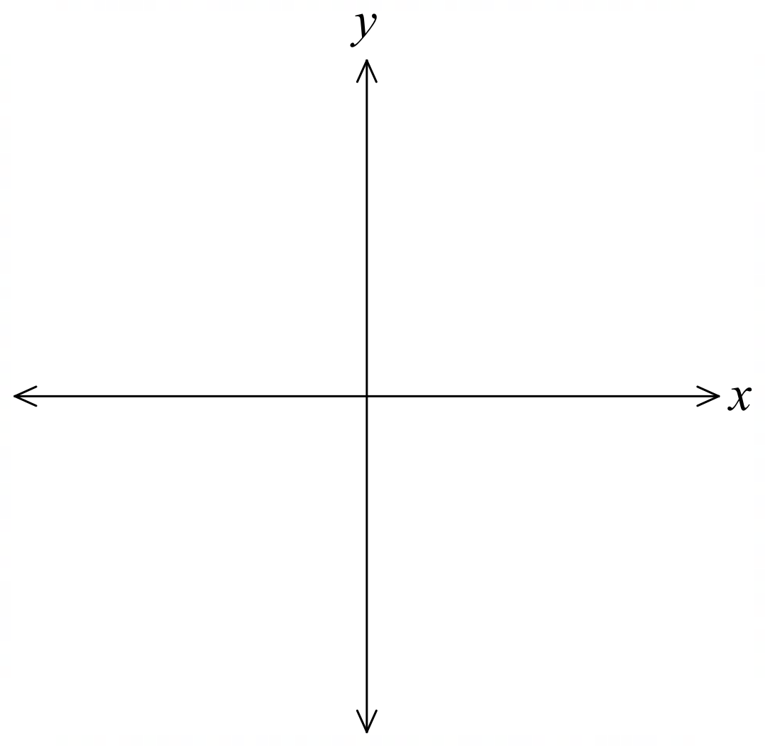
- The triangle ABC has vertices A(−1, 0), B(3, 2) and C(4, 0).
Calculate the gradient of each side, and hence show that ∆ABC is a right-angled triangle.

$$m_{AB}=\frac{2-0}{3-\left(-1\right)}=\frac{1}{2}$$
$$m_{BC}=\frac{0-2}{4-3}= -2$$
$$m_{CA}=\frac{0-0}{4-\left(-1\right)}= 0$$
$$m_{AB}× m_{BC}=\frac{1}{2}× \left(-2\right)= -1$$
AB ⊥ BC, so ΔABC is right-angled at B.

  - Find the length of each side of the triangle formed by $P\left(0, 3\right), Q\left(1, 7\right) and R\left(5, 8\right)$.
  - Hence show that $ΔPQR$ is isosceles.

$$PQ = \sqrt{{\left(1-0\right)}^{2}+ {\left(7-3\right)}^{2}}= \sqrt{17}$$
$$QR = \sqrt{{\left(5-1\right)}^{2}+ {\left(8-7\right)}^{2}}= \sqrt{17}$$
$$PR = \sqrt{{\left(5-0\right)}^{2}+ {\left(8-3\right)}^{2}}= \sqrt{50}$$
$PQ = QR = \sqrt{17}$, so ΔPQR is isosceles.
- Prove that $A\left(1,-1\right), B\left(-1,1\right), C\left(-\sqrt{3},-\sqrt{3}\right)$ form an equilateral triangle.

$$AB = \sqrt{{\left(-1-1\right)}^{2}+ {\left(1-\left(-1\right)\right)}^{2}}=\sqrt{8}$$
$$BC = \sqrt{{\left(-\sqrt{3}-\left(-1\right)\right)}^{2}+ {\left(-\sqrt{3}-1\right)}^{2}}=\sqrt{8}$$
$$CA = \sqrt{{\left(1-\left(-\sqrt{3}\right)\right)}^{2}+ {\left(-1-\left(-\sqrt{3}\right)\right)}^{2}}=\sqrt{8}$$
AB = BC = CA = $\sqrt{8}$, so equilateral.
- The three lines with equations $y=0, y=x+2 and y=-2x+5$ are illustrated here.
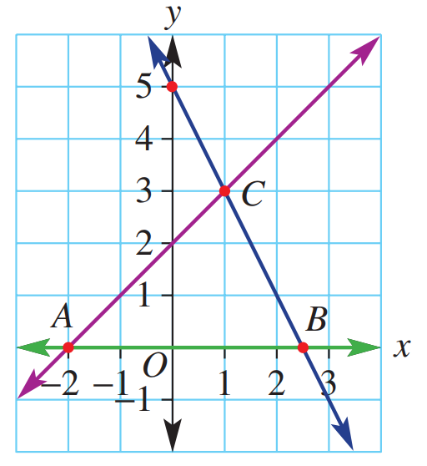
  - State the coordinates of the intersection point of
$y=x+2$ and $y=-2x+5$.
Intersection point at (1,3)

  - Use the formula for the area of a triangle to
calculate the area of the enclosed region $ΔACB$

Area = $\frac{1}{2}$ $bh=$ $\frac{1}{2}$ $\left(4.5\right)\left(3\right)=$ $6.75$ square units

Development
- Consider a triangle ∆XYZ with vertices $X\left(0, -4\right), Y\left(4, 2\right) and Z\left(-2, 6\right)$.
  - Find the side lengths.
  - Show that $∆XYZ$ is a right-angled isosceles triangle by showing that its side lengths satisfy Pythagoras’ theorem.
  - Hence find the area of $∆XYZ$.
$$XY = \sqrt{{\left(4-0\right)}^{2}+ {\left(2-\left(-4\right)\right)}^{2}}= \sqrt{52}$$
$$YZ = \sqrt{{\left(-2-4\right)}^{2}+ {\left(6-2\right)}^{2}}= \sqrt{52}$$
$$XZ = \sqrt{{\left(-2-0\right)}^{2}+ {\left(6-\left(-4\right)\right)}^{2}}= \sqrt{104}$$
$$XY² + YZ² = 52 + 52 = 104 = XZ²$$
By Pythagoras' theorem, ΔXYZ is right-angled.
Area = $\frac{1}{2\left(XY\right)\left(YZ\right)}$ $=$ $\frac{1}{2}$ $\left(2\sqrt{13}\right)\left(2\sqrt{13}\right)= 26$square units
- The triangle $ABC$ has vertices $A\left(-1, 0\right), B\left(3, 2\right) and C\left(4, 0\right)$.
  - Calculate the gradient of each side,
  - Explain why $∆ABC$ is a right-angled triangle.

$$m_{AB}=\frac{2-0}{3-\left(-1\right)}=\frac{1}{2}$$
$$m_{BC}=\frac{0-2}{4-3}= -2$$
$$m_{CA}=\frac{0-0}{-1-4}= 0$$
$$m_{AB}× m_{BC}=\frac{1}{2}× \left(-2\right)= -1$$
AB ⊥ BC, so ΔABC is right-angled at B.
- Show that the triangle with vertices A(1, 0), B(6, 5) and C(0, 2) is right-angled by:
- Using Pythagoras’ Theorem.  $$AB^{2}= {\left(6-1\right)}^{2}+ {\left(5-0\right)}^{2}= 50$$  $$BC^{2}= {\left(0-6\right)}^{2}+ {\left(2-5\right)}^{2}= 45$$  $$CA^{2}= {\left(1-0\right)}^{2}+ {\left(0-2\right)}^{2}= 5$$  $$AB² = BC² + CA^{2}$$  $$50 = 45 + 5$$  By Pythagoras' theorem, triangle is right-angled at C. | - Using the gradients of two sides.  $$m_{BC}=\frac{2-5}{0-6}=\frac{1}{2}$$  $$m_{CA}=\frac{0-2}{1-0}= -2$$  $$m_{BC}× m_{CA}=\frac{1}{2}× \left(-2\right)= -1$$  BC ⊥ CA, so triangle is right-angled at C.

- The vertices of $ΔABC$ are $A\left(0,0\right), B\left(3,4\right)$ and $C\left(\frac{25}{3}, 0\right)$
  - Find the gradient of:
- $AB$  $$m_{AB}=\frac{4-0}{3-0}=\frac{4}{3}$$ | - $BC$  $$m_{BC}=\frac{0-4}{\frac{25}{3}-3}= -\frac{3}{4}$$ | - $CA$  $$m_{CA}=\frac{0-0}{0-\frac{25}{3}}= 0$$

  - What type of triangle is $ΔABC$? Why?

$$m_{AB}× m_{BC}=\frac{4}{3}× \left(-\frac{3}{4}\right)= -1$$
AB ⊥ BC, so ΔABC is right-angled at B.
  - Find the perimeter of $ΔABC$.

$$AB = \sqrt{3^{2}+ 4^{2}}= 5$$
$$BC = \sqrt{{\left(\frac{16}{3}\right)}^{2}+ 4^{2}}=\frac{20}{3}$$
$$CA =\frac{25}{3}$$
$$Perimeter = 5 +\frac{20}{3}+\frac{25}{3}= 20 units$$
- Each set of three points given below forms a triangle that is either
isosceles, equilateral, right-angled, or none of the above.
Find the side lengths of each triangle and hence determine its type.
- $A\left(-1, 0\right), B\left(1, 0\right), C\left(0, \sqrt{3}\right)$  $AB=$  $BC=$  $AC=$  $$AB = \sqrt{{\left(1-\left(-1\right)\right)}^{2}+ {\left(0-0\right)}^{2}}= 2$$  $$BC = \sqrt{{\left(0-1\right)}^{2}+ {\left(\sqrt{3}-0\right)}^{2}}= 2$$  $$AC = \sqrt{{\left(0-\left(-1\right)\right)}^{2}+ {\left(\sqrt{3}-0\right)}^{2}}= 2$$  Equilateral triangle (all sides equal) | - $P\left(-1, 1\right), Q\left(0, -1\right), R\left(3, 3\right)$  $$PQ = \sqrt{{\left(0-\left(-1\right)\right)}^{2}+ {\left(-1-1\right)}^{2}}= \sqrt{5}$$  $$QR = √((3-0)² + (3-(-1))²) = 5$$  $$PR = √((3-(-1))² + (3-1)²) = √20 = 2\sqrt{5}$$  $$PQ² + PR² = 5 + 20 = 25 = QR²$$  $$Right-angled triangle at P$$
- $D\left(1, 1\right), E(2, -2), F\left(-3, 0\right)$  $$DE = \sqrt{{\left(2-1\right)}^{2}+ {\left(-2-1\right)}^{2}}= \sqrt{10}$$  $$EF = \sqrt{{\left(-3-2\right)}^{2}+ {\left(0-\left(-2\right)\right)}^{2}}= \sqrt{29}$$  $$DF = \sqrt{{\left(-3-1\right)}^{2}+ {\left(0-1\right)}^{2}}= \sqrt{17}$$  scalene | - $X\left(-3, -1\right), Y\left(0, 0\right), Z\left(-2, 2\right)$  $$XY = \sqrt{{\left(0-\left(-3\right)\right)}^{2}+ {\left(0-\left(-1\right)\right)}^{2}}= \sqrt{10}$$  $$YZ = \sqrt{{\left(-2-0\right)}^{2}+ {\left(2-0\right)}^{2}}= \sqrt{8}$$  $$XZ = \sqrt{{\left(-2-\left(-3\right)\right)}^{2}+ {\left(2-\left(-1\right)\right)}^{2}}= \sqrt{10}$$  Isosceles
- Find the gradients of the three lines $5x-7y+5=0, 2x-5y+7=0 and 7x+5y+2=0$. Show that they enclose a right-angled triangle.

$$Line 1: 5x - 7y + 5 = 0 → m_{1}=\frac{5}{7}$$
$$Line 2: 2x - 5y + 7 = 0 → m_{2}=\frac{2}{5}$$
$$Line 3: 7x + 5y + 2 = 0 → m₃ = -\frac{7}{5}$$
$$m_{1}× m_{3}=\frac{5}{7}× \left(-\frac{7}{5}\right)= -1$$
Lines 1 and 3 are perpendicular, so triangle is right-angled.
- A right-angled isosceles triangle has vertices at $A\left(0,3\right)$, $B\left(3,0\right)$ and $C\left(-3,0\right)$.
Find the equation of each side.
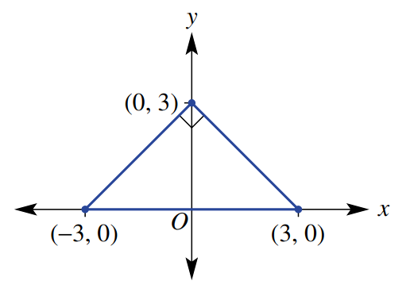

$$AB: m =\frac{0-3}{3-0}= -1, passes through \left(0,3\right): y = -x + 3$$
$$AC: m =\frac{0-3}{-3-0}= 1, passes through \left(0,3\right): y = x+ 3$$
$$BC: horizontal through \left(-3,0\right): y = 0$$

- The lines $k$ and $l$ are shown in the diagram. Find:
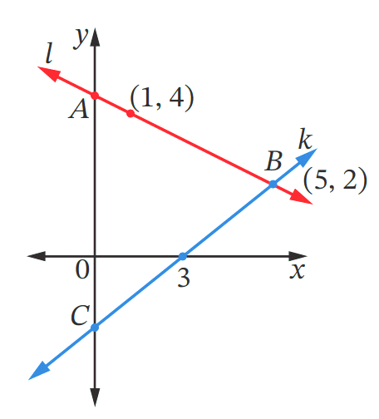
  - The equation of line $k$, in general form.

$x-y-3=0$
  - The equation of line $l$, in general form.

$x+2y-9=0$
  - The coordinates of point $A$.

$$\left(0,4.5\right)$$
  - The coordinates of point $C$.

$$\left(0,-3\right)$$
  - The area of $ΔABC$.

18.75 square units

Mastery
- Find the area of $ΔABC$.
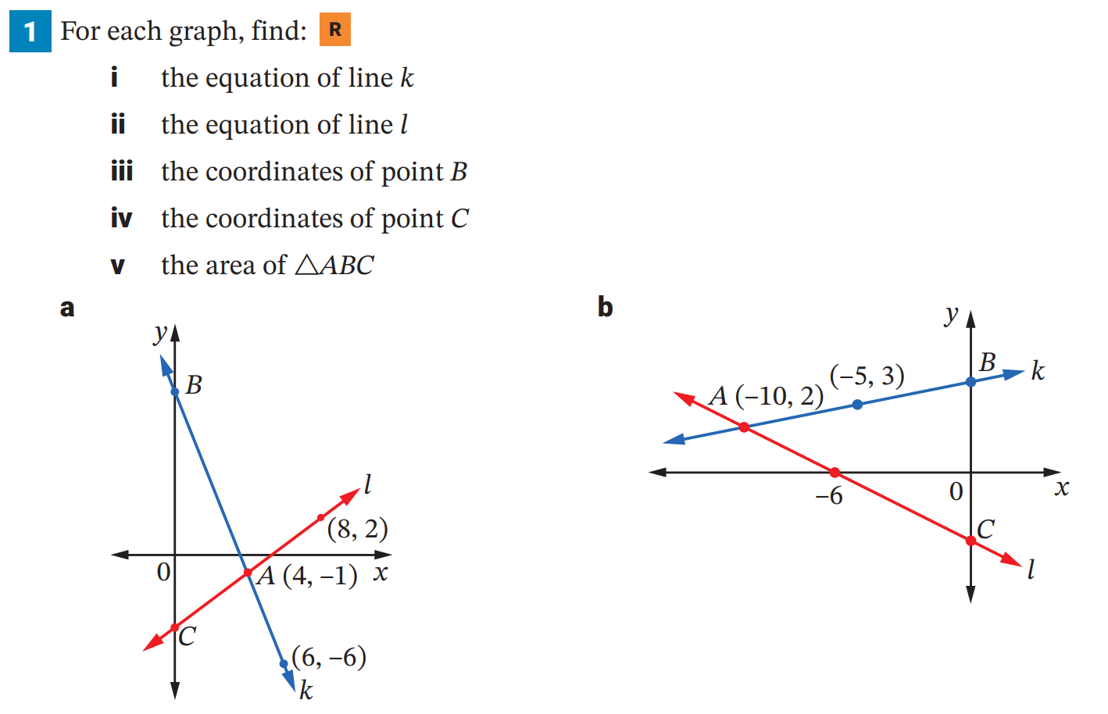  26 square units | 35 square units

Coordinate Geometry Problems: Quadrilaterals

- Types of Quadrilaterals and their Properties
Type of Quadrilateral | Definitions
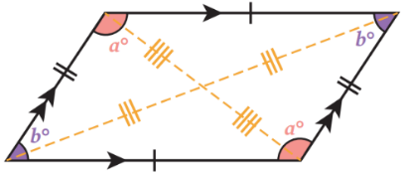  Parallelogram | Two pairs of opposite sides parallel or  The opposite sides are equal, or  One pair of opposite sides are equal and parallel, or  The diagonals bisect each other
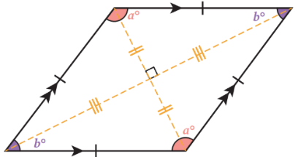  Rhombus | All sides are equal or  Two pairs of opposite sides parallel and one pair of adjacent sides equal, or  The diagonals bisect each other at right angles
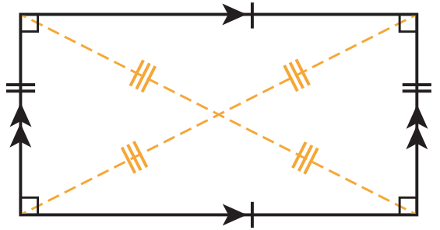  Rectangle | Two pairs of opposite sides parallel and one angle a right angle or  The diagonals are equal and bisect each other
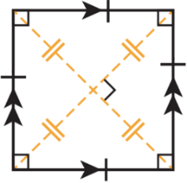  Square | Two pairs of opposite sides parallel and one pair of adjacent sides equal and one angle a right angle

- Diagonals Bisect Each Other
Two diagonals bisect (cut each other in half) when their midpoints are the same point.
$$M=\left(\frac{x_{1}+x_{2}}{2},\frac{y_{1}+y_{2}}{2}\right)$$

- Example Solve coordinate geometry problems involving quadrilaterals
Show that the quadrilateral with vertices $A(1, 2), B(5, 4), C(7, 0)$ and $D(3, -2)$ is a rhombus.
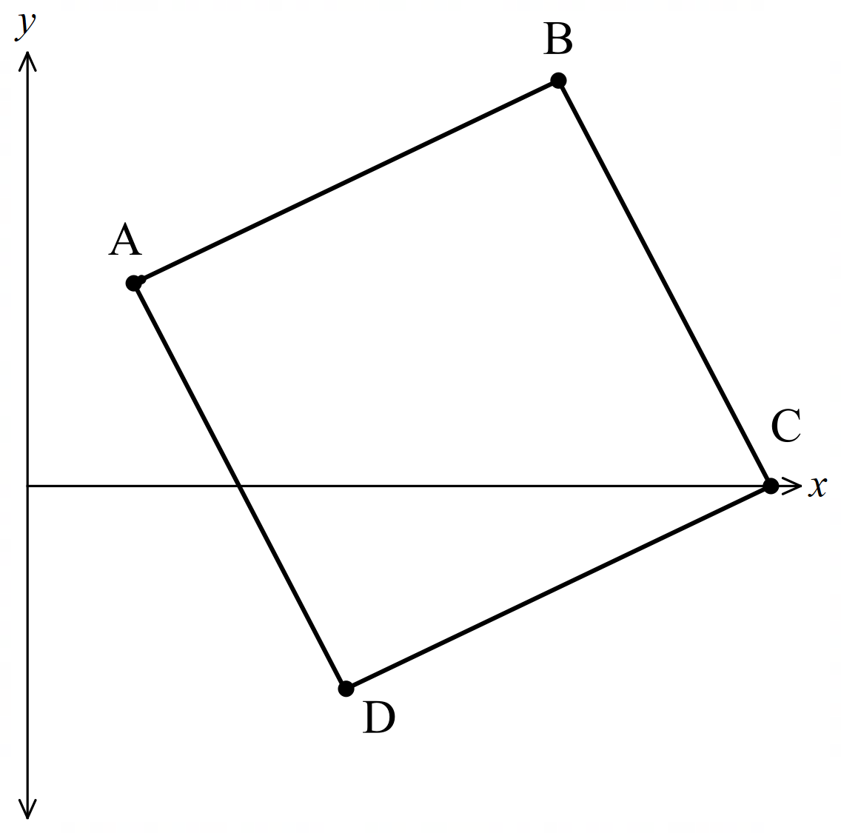
Easiest way is to show that all four sides are equal.
$$AB = \sqrt{{\left(5-1\right)}^{2}+ {\left(4-2\right)}^{2}}= \sqrt{20}$$
$$BC = \sqrt{{\left(7-5\right)}^{2}+ {\left(0-4\right)}^{2}}= \sqrt{20}$$
$$CD = \sqrt{{\left(3-7\right)}^{2}+ {\left(-2-0\right)}^{2}}= \sqrt{20}$$
$$DA = \sqrt{{\left(1-3\right)}^{2}+ {\left(2-\left(-2\right)\right)}^{2}}= \sqrt{20}$$
∴ ABCD is a rhombus (all sides equal)

- Guided Practice
- Show that the quadrilateral with vertices E(1, 1), F(5, 3), G(7, −1) and H(3, −3) is a parallelogram by showing its diagonals bisect each other.

- Show that the quadrilateral with vertices P(1, 3), Q(5, 5), R(6, 3) and S(2, 1) is a rectangle by showing two pairs of opposite sides parallel and one pair of adjacent sides perpendicular.

Foundation
- $A\left(-3,0\right), B\left(1,6\right), C(4,4)$ and $D\left(0,-2\right)$ are the vertices of a rectangle.
  - Find the lengths of $AC$ and $BD$ and show that the diagonals are equal.
  - Find the midpoints of the diagonals $AC$ and $BD$.
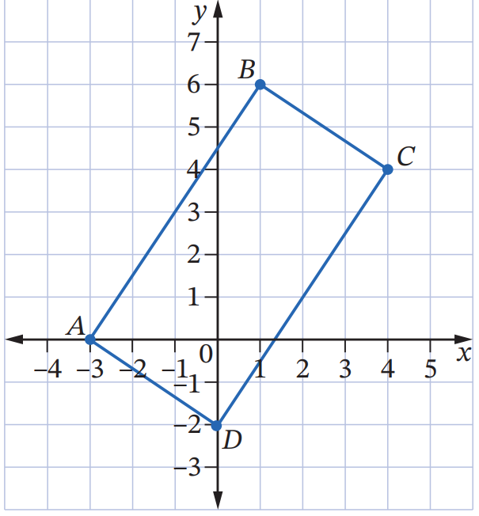
  - What property of rectangles have you shown?
$$AC = \sqrt{{\left(4-\left(-3\right)\right)}^{2}+ {\left(4-0\right)}^{2}}= \sqrt{65}$$
$$BD = \sqrt{{\left(0-1\right)}^{2}+ {\left(-2-6\right)}^{2}}= \sqrt{65}$$
Diagonals are equal.

$$Midpoint of AC = \left(\frac{-3+4}{2},\frac{0+4}{2}\right)= \left(\frac{1}{2}, 2\right)$$
$$Midpoint of BD = \left(\frac{1+0}{2},\frac{6+\left(-2\right)}{2}\right)= \left(\frac{1}{2}, 2\right)$$

The diagonals of a rectangle are equal and bisect each other.
- The vertices of a rhombus are $D\left(-4,2\right), E\left(1,2\right), F(4,-2)$ and $G\left(-1,-2\right)$
  - Show that all side lengths are equal.
  - By finding the gradients, show that the opposite sides are parallel.
  - Show that the diagonals $DF$ and $GE$ are perpendicular.
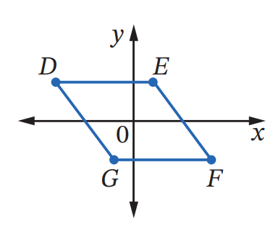
  - Show that the midpoints of $DF$ and $GE$ intersect at the same point (diagonals bisect).
$$DE = \sqrt{{\left(1-\left(-4\right)\right)}^{2}+ {\left(2-2\right)}^{2}}= 5$$
$$EF = \sqrt{{\left(4-1\right)}^{2}+ {\left(-2-2\right)}^{2}}= 5$$
$$FG = \sqrt{{\left(-1-4\right)}^{2}+ {\left(-2-\left(-2\right)\right)}^{2}}= 5$$
$$GD = \sqrt{{\left(-4-\left(-1\right)\right)}^{2}+ {\left(2-\left(-2\right)\right)}^{2}}= 5$$
All sides equal.

$$m_{DE}=\frac{2-2}{1-\left(-4\right)}= 0$$
$$m_{EF}=\frac{-2-2}{4-1}= -\frac{4}{3}$$
$$m_{FG}=\frac{-2-\left(-2\right)}{-1-4}= 0$$
$$m_{GD}=\frac{2-\left(-2\right)}{-4-\left(-1\right)}= -\frac{4}{3}$$
$$m_{DE}= m_{FG} and m_{EF}= m_{GD}, so opposite sides are parallel.$$

$$m_{DF}=\frac{-2-2}{4-\left(-4\right)}= -\frac{1}{2}$$
$$m_{GE}=\frac{2-\left(-2\right)}{1-\left(-1\right)}= 2$$
$$m_{DF}× m_{GE}= -\frac{1}{2}× 2 = -1$$
Diagonals are perpendicular.

$$Midpoint of DF = \left(\frac{-4+4}{2},\frac{2+\left(-2\right)}{2}\right)= \left(0, 0\right)$$
$$Midpoint of GE = \left(\frac{-1+1}{2},\frac{-2+2}{2}\right)= \left(0, 0\right)$$
Diagonals bisect each other.

Development
- A square has vertices $A\left(2,-3\right), B\left(6,3\right), C\left(0,7\right)$ and $D\left(-4,1\right)$
  - Show that the diagonals are equal.
  - Show that its diagonals meet at right angles.
  - Show that the diagonals bisect each other.
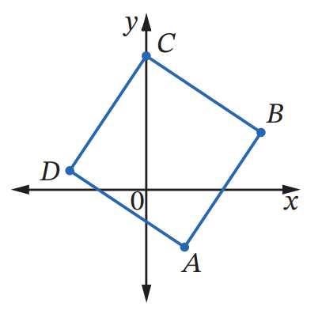
  - Hence explain why $ABCD$ must be a square.
$$AC = \sqrt{{\left(0-2\right)}^{2}+ {\left(7-\left(-3\right)\right)}^{2}}= \sqrt{104}= 2\sqrt{26}$$
$$BD = \sqrt{{\left(-4-6\right)}^{2}+ {\left(1-3\right)}^{2}}= \sqrt{104}= 2\sqrt{26}$$
Diagonals are equal.

$$m_{AC}=\frac{7-\left(-3\right)}{0-2}= -5$$
$$m_{BD}=\frac{1-3}{-4-6}=\frac{1}{5}$$
$$m_{AC}× m_{BD}= -5 ×\frac{1}{5}= -1$$
Diagonals meet at right angles.

$$Midpoint of AC = \left(\frac{2+0}{2},\frac{-3+7}{2}\right)= \left(1, 2\right)$$
$$Midpoint of BD = \left(\frac{6+\left(-4\right)}{2},\frac{3+1}{2}\right)= \left(1, 2\right)$$
Diagonals bisect each other.

ABCD has equal diagonals that bisect each other at right angles, so ABCD is a square.

- Consider a quadrilateral $ABCD$. $A\left(4, 9\right), B\left(0, 4\right), C\left(-2, 3\right)$ and $D\left(2, 8\right).$
  - Find the midpoint of the interval joining $A\left(4, 9\right)$ and $C\left(-2, 3\right).$
  - Find the midpoint of the interval joining $B\left(0, 4\right)$ and $D\left(2, 8\right).$
  - What can you conclude about the diagonals of the quadrilateral?
  - Explain why $ABCD$ must be a parallelogram.

$$Midpoint of AC = \left(\frac{4+\left(-2\right)}{2},\frac{9+3}{2}\right)= \left(1, 6\right)$$

$$Midpoint of BD = \left(\frac{0+2}{2},\frac{4+8}{2}\right)= \left(1, 6\right)$$

The diagonals bisect each other.

Since the diagonals bisect each other, ABCD is a parallelogram.

- The points $A\left(3, 1\right)$, $B\left(10, 2\right),$ $C\left(5, 7\right)$ and $D\left(-2, 6\right)$ are the vertices of a quadrilateral.
  - Find the lengths of all four sides.
  - Explain why ABCD is a rhombus.
$$AB = \sqrt{{\left(10-3\right)}^{2}+ {\left(2-1\right)}^{2}}= \sqrt{50}$$
$$BC = \sqrt{{\left(5-10\right)}^{2}+ {\left(7-2\right)}^{2}}= \sqrt{50}$$
$$CD = \sqrt{{\left(-2-5\right)}^{2}+ {\left(6-7\right)}^{2}}= \sqrt{50}$$
$$DA = \sqrt{{\left(3-\left(-2\right)\right)}^{2}+ {\left(1-6\right)}^{2}}= \sqrt{50}$$

All four sides are equal, so ABCD is a rhombus.

- Show that $A\left(2, 5\right)$, $B\left(3, 7\right)$, $C\left(-4, -1\right)$ and $D\left(-5, 2\right)$ do not form a parallelogram.

$$Midpoint of AC = \left(\frac{2+\left(-4\right)}{2},\frac{5+\left(-1\right)}{2}\right)= \left(-1, 2\right)$$
$$Midpoint of BD = \left(\frac{3+\left(-5\right)}{2},\frac{7+2}{2}\right)= \left(-1,\frac{9}{2}\right)$$
Diagonals do not bisect each other, so ABCD is not a parallelogram.

- The quadrilateral ABCD has vertices $A(-1, 1), B(3, -1), C(5, 3)$ and $D(1, 5).$
  - Show that the opposite sides are parallel, and hence that ABCD is a parallelogram.
  - Show that AB ⟂ BC, and hence that ABCD is a rectangle.
  - Show that AB = BC, and hence that ABCD is a square.

$$m_{AB}=\frac{-1-1}{3-\left(-1\right)}= -\frac{1}{2}$$
$$m_{DC}=\frac{5-3}{1-5}= -\frac{1}{2}$$
$$m_{BC}=\frac{3-\left(-1\right)}{5-3}= 2$$
$$m_{AD}=\frac{5-1}{1-\left(-1\right)}= 2$$
$m_{AB} = m_{DC} and m_{BC} = m_{AD}$, so opposite sides are parallel.
ABCD is a parallelogram.

$$m_{AB}× m_{BC}= -\frac{1}{2}× 2 = -1$$
AB ⊥ BC, so ABCD is a rectangle (parallelogram with adjacent sides perpendicular)

$$AB = \sqrt{{\left(3-\left(-1\right)\right)}^{2}+ {\left(-1-1\right)}^{2}}= \sqrt{20}$$
$$BC = \sqrt{{\left(5-3\right)}^{2}+ {\left(3-\left(-1\right)\right)}^{2}}= \sqrt{20}$$
AB = BC, so ABCD is a square (rectangle with adjacent sides equal)

- A quadrilateral, $ABCD,$has vertices $A\left(2,7\right), B\left(4,9\right), C(8,5)$and $D\left(6,3\right)$.
  - Find the gradient of:
- $AB$  1 | - $BC$  $$-1$$ | - $CD$  1 | - $DA$  $$-1$$
  - What type of quadrilateral is $ABCD$?

rectangle
  - Explain why.

Opposites are parallel and adjacent sides are perpendicular

- Find the gradients of these four lines and explain why the quadrilateral formed by the four lines must be a rectangle.
$4x-3y+10=0, 3x+4y+7=0, 4x-3y-7=0, 3x+4y+1=0$
$$Line 1: 4x - 3y + 10 = 0 → m_{1}=\frac{4}{3}$$
$$Line 2: 3x + 4y + 7 = 0 → m_{2} = -\frac{3}{4}$$
$$Line 3: 4x - 3y - 7 = 0 → m_{3}=\frac{4}{3}$$
$$Line 4: 3x + 4y + 1 = 0 → m₄ = -\frac{3}{4}$$
$m₁ = m₃$ and $m₂ = m₄$, so opposite sides are parallel.
$m_{1}× m_{2}=\frac{4}{3}× \left(-\frac{3}{4}\right)= -1$, so adjacent sides are perpendicular.
The quadrilateral is a rectangle.
- A quadrilateral has vertices $P\left(-7,2\right), Q\left(2,-7\right), R\left(5,-4\right)$ and $S\left(-4,5\right)$.
  - Find the lengths of $PR$ and $QS$ in surd form.
  - Find the midpoints of $PR$and $QS$.
  - Is $PR$ perpendicular to $QS$? Explain why.
  - What type of quadrilateral is $PQRS$? Explain.
$$PR = \sqrt{{\left(5-\left(-7\right)\right)}^{2}+ {\left(-4-2\right)}^{2}}=\sqrt{180}$$
$$QS = \sqrt{{\left(-4-2\right)}^{2}+ {\left(5-\left(-7\right)\right)}^{2}}=\sqrt{180}$$

$$Midpoint of PR = \left(\frac{-7+5}{2},\frac{2+\left(-4\right)}{2}\right)= \left(-1, -1\right)$$
$$Midpoint of QS = \left(\frac{2+\left(-4\right)}{2},\frac{-7+5}{2}\right)= \left(-1, -1\right)$$

$$m_{PR}=\frac{-4-2}{5-\left(-7\right)}= -\frac{1}{2}$$
$$m_{QS}=\frac{5-\left(-7\right)}{-4-2}=-2$$
PR is not perpendicular to QS (product of gradients ≠ -1).

PQRS is a rectangle (not a rhombus)
The diagonals PR and QS are equal length and bisect each other at $(-1, -1)$

Mastery
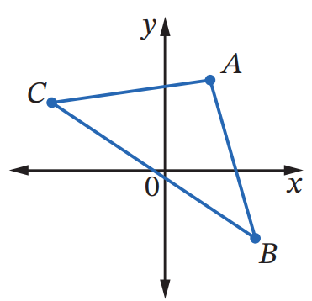
- A quadrilateral has vertices $C\left(2,6\right), D\left(-5,2\right), E\left(-1,-5\right)$ and $F\left(6,-1\right)$
  - Find the length of each diagonal.
  - Find the midpoint of each diagonal.
  - Show that the diagonals are perpendicular.
  - What type of quadrilateral is $PQRS$? Explain.

$$CE = \sqrt{{\left(-1-2\right)}^{2}+ {\left(-5-6\right)}^{2}}= \sqrt{130}$$
$$DF = \sqrt{{\left(6-\left(-5\right)\right)}^{2}+ {\left(-1-2\right)}^{2}}= \sqrt{130}$$

$$Midpoint of CE = \left(\frac{2+\left(-1\right)}{2},\frac{6+\left(-5\right)}{2}\right)= \left(\frac{1}{2},\frac{1}{2}\right)$$
$$Midpoint of DF = \left(\frac{-5+6}{2},\frac{2+\left(-1\right)}{2}\right)= \left(\frac{1}{2},\frac{1}{2}\right)$$

$$m_{CE}=\frac{-5-6}{-1-2}=\frac{11}{3}$$
$$m_{DF}=\frac{-1-2}{6-\left(-5\right)}= -\frac{3}{11}$$
$$m_{CE}× m_{DF}=\frac{11}{3}× \left(-\frac{3}{11}\right)= -1$$
Therefore diagonals are perpendicular.

CDEF is a rhombus (diagonals equal length, bisect each other, and are perpendicular)
- $A\left(2,4\right), B\left(4,-3\right),$and $C\left(-5,3\right)$ are the vertices of a triangle.
  - $X$ and $Y$ are midpoints of $AB$ and $AC$ respectively.
Find the coordinates of $X$ and $Y$.
  - Find the gradients of $XY$ and $CB$.
  - What type of quadrilateral is $XYBC$?
  - Find the lengths of $XY$ and $CB$. Hence show that $CB=2XY$.
$$X= \left(\frac{2+4}{2},\frac{4+\left(-3\right)}{2}\right)= \left(3,\frac{1}{2}\right)$$
$$Y= \left(\frac{2+\left(-5\right)}{2},\frac{4+3}{2}\right)= \left(-\frac{3}{2},\frac{7}{2}\right)$$

$$Gradient XY =\frac{\frac{7}{2}-\frac{1}{2}}{-\frac{3}{2}- 3}= -\frac{2}{3}$$
$$Gradient CB =\frac{3 - \left(-3\right)}{-5 - 4}= -\frac{2}{3}$$

XY and CB are parallel, so XYBC is a trapezium

$$Length XY = \sqrt{{\left(-\frac{3}{2}- 3\right)}^{2}+ {\left(\frac{7}{2}-\frac{1}{2}\right)}^{2}}=\frac{3\sqrt{13}}{2}$$
Length CB = $\sqrt{{\left(-5 - 4\right)}^{2}+ {\left(3 - \left(-3\right)\right)}^{2}}= 3\sqrt{13}$
$$∴CB = 2XY$$
- The quadrilateral $ABCD$ has vertices $A(1, -4), B(3, 2), C(-5, 6)$ and $D(-1, -2)$.
  - Find the midpoints P of AB, Q of BC, R of CD, and S of DA.
  - Prove that PQRS is a parallelogram by showing that PQ‖RS and PS‖QR.

$$P = \left(\frac{1 + 3}{2},\frac{-4 + 2}{2}\right)= \left(2, -1\right)$$
$$Q = \left(\frac{3 + \left(-5\right)}{2},\frac{2 + 6}{2}\right)= \left(-1, 4\right)$$
$$R = \left(\frac{-5 + \left(-1\right)}{2},\frac{6 + \left(-2\right)}{2}\right)= \left(-3, 2\right)$$
$$S = \left(\frac{-1 + 1}{2},\frac{-2 + \left(-4\right)}{2}\right)= \left(0, -3\right)$$

$$m_{PQ}=\frac{4 - \left(-1\right)}{-1 - 2}=-\frac{5}{3}$$
$$m_{RS}=\frac{-3 - 2}{0 - \left(-3\right)}= -\frac{5}{3}$$
$$PQ ∥ RS since m_{PQ}= m_{RS}$$
$$m_{PS}=\frac{-3 - \left(-1\right)}{0 - 2}= -\frac{2}{-2}= 1$$
$$m_{QR}=\frac{2 - 4}{-3 - \left(-1\right)}= 1$$
$$PS ∥ QR since m_{PS}= m_{QR}$$
PQRS is a parallelogram since opposite sides are parallel.

- Explain why the four lines $l_{1}: y=x+1, l_{2}:y=x-3, l_{3}:y=3x+5$and $l_{4}:y=3x-5$ enclose a parallelogram. Then find the vertices of this parallelogram.

$l₁ ∥ l₂ and l₃ ∥ l₄,$ so opposite sides are parallel
The four lines enclose a parallelogram
Solve simultaneously to find point of intersection:
$$l_{1}= l_{3}: x + 1 = 3x + 5$$
$$x = -2, y = -1$$
$$Vertex \left(-2, -1\right)$$
$$l_{1}= l_{4}: x + 1 = 3x - 5$$
$$x = 3, y = 4$$
$$Vertex \left(3, 4\right)$$
$$l_{2}= l_{3}: x - 3 = 3x + 5$$
$$x = -4, y = -7$$
$$Vertex \left(-4, -7\right)$$
$$l_{2}= l_{4}: x - 3 = 3x - 5$$
$$x = 1, y = -2$$
$$Vertex \left(1, -2\right)$$
$$Vertices: (-2, -1), (3, 4), (-4, -7), \left(1, -2\right)$$

